# 

**Initiating Notes 2**

**Earnings 3**

EA 2Q25 Review 4

EA 1Q25 Review 7

**Thesis 9**

**Model Review 12**

Evan Memo Questions 14

**Conferences/Meetings 15**

9.19.24 - Call w/ BAML 15

9.17.24 - EA Investor Day 16

9.4.24 - Call w/ Mscience/Corey 20

8.15.24 - EA hosted by TD Cowen 22

8.12.24 - EA @ OpCo 24

6.18.24 - MN hosts EA Mgmt 26

5.21.24 - EA @ JPM 26

5.23.24 - EA CFO @ Stifel 27

**FC 30**

# 

# Initiating Notes

**Madden**

* Bookings
  + American Football (Madden + CFB) Guided to $1B of Bookings for F25/C24
* Madden Units
  + typically sell 7-10M units
* Madden Ultimate Team
  + Idea/Goal is to build the best team(s) and win in matches and in a competitive marketplace you can lose to players who outspend you on players/teams
  + **Reasons to Purchase**: Although technically can play without spend, building a top-tier team requires either (i) significant time or (ii) real-game spend
    - Pay to Win: Having a better team/players helps player win in head-to-head matches
    - Unique Event Items: Super Bowl theme promotions or unique abilities
    - Recreate your team: Theme team of all Dallas Cowboy players
  + What to Purchase
    - Card Packs (earned in-game currency or real currency): player cards, team items and other game content. quality of cards vary

**College Football**

* Game Modes
  + Dynasty: Use a coach to build a top-tier football program
  + Road-to-Glory: Student-athletic (manage GPA, image, Coach trust and get a Heisman)
  + CFB [Ultimate Team](https://www.ea.com/games/ea-sports-college-football/college-football-25/news/college-football-25-ultimate-team): Build top tier team
* CFB / Madden Cannibalization: College may have structurally lower monetization based on current ultimate team mechanics
  + Madden Pullforward: Positive reception of CFB (>5M units sold) created hype in stock as earlier launch (Aug vs. Sept) led to uptick in CFB units & pullfwd in Madden Units
  + **Engagement Cannibalization: Madden monetizes primarily through Ultimate team and I suspect the lack of diversity among desirable players limits game’s long-term monetization**
    - Appeal Drivers: Ultimate team monetization built around user desire to acquire a player/team-composite and NFL teams have higher/nationa-affinity than more regionalized college teams. E.g. Mahomes, Kelces, Brady appeal outside of their regions vs. College football players who have a much shorter college career duration
      * **NFL Regular / Prime time games get 15M / 40M Viewers**
      * **College Top Prime-time Games get 5-10M**
    - Psychological Drivers: Madden psychological drivers dynamics support a “winning team” you want to beat players H2H, whereas the College football focused on a “theme team”

# 

# Earnings

Very filibustered call but highlights below:

---

* Investor day - Sept24 in NYC
* EA does not capitalize SW costs -- fully expensed in P&L
* Believe we can get Apex back to growth
* F25 Guide for +Lsd w/ weak content slate
* Why is Apex single-player mode coming back for S21
  + Respawn team more open to listening to player demand
* Underlying mobile expectations - TAM and market share
  + We expect market is l/msd growth in CY24
  + Mobile is hard b/c requires a lot of CAC investment to ramp a new game
  + High CAC + long ramp isn't conducive for standing up games
* Linearity for Bookings in F26/27
  + We can expand OM by 150-200bps after F25
  + New IP in pipeline should give us leverage in later years
* AI initiatives
  + Can build stadiums in 6 weeks from 6 months
  + 1st application of AI is speed to deployment and cost savings
  + We believe there's an impact across 50% of our development processes
* Advertising oppt in gaming?
  + Still early on that front
  + We are careful of advertising impact on experience/engagement
* Opportunity to expand IP to media

## 

## EA 2Q25 Review

**Net**: Raised FY25 Bookings guide by 100M (incl 41M of 1H beats). EA expects American Football to be >$1B this FY and for FC franchise (incl. mobile) to grow this year. Apex expectations reset lower (“to remain at msd”). EA is guided to +4.5%/+10% in 3Q/4Q (cons +7%/+8%). Growth curve now suggest acceleration exiting 4Q with ~60M stronger 2H vs. initial guide

**Shares**: Shares are up +3% and my F26/27 EPS is up 2-3%

2Q25 Results

* Bookings BEAT by 49M/2.4% at +14.2% (cons +11.6% | our: +16.0%) but missed Mscience at +17.5%
* Mobile BEAT at +3% (cons +2%)
* Live Services b.f. mobile CRUSHED at +10.5% (cons -1.6% | our +3% | Mscience + 8%)
* EBIT/OM BEAT at 691m/33.2% (cons 643M/31.7%)
* EPS BEAT at $2.15 (Cons $2.02)

3Q25 Guide

* Bookings GUIDED BELOW at +1.4% - 7.8% (cons: 7% vs. MP: +4.5%)
* GM GUIDED ABOVE at 81.8% (cons +80.7%)
* Opex GUIDED IN-LINE at MP 935M (cons 929M)

4Q25 Guide

* Bookings GUIDED AHEAD at +5.5% - 14.5% (cons: 8% vs. MP: +10%)
* GM GUIDED BELOW above at 81.8% (cons +80.7%)
* Opex GUIDED ABOVE at 938M (cons 904M)

FY25 Guide

* Booking raised by 100M at HE after beating 1H25 HE by 41M (12M/29M in 1Q/2Q)
  + *Now LE goes from -2% to +1% eliminating ex-growth scenario*
* GM seems to be modestly lower/in-line
* Opex gets a ~2% raise
* EBT is modestly lower ~1%

Model Changes (F2025)

* Bookings moves up 65M/0.8% to +6% y/y (cons +6%)
* EPS moves up 1% to $8.65 (cons 8.64)

PT & Recommendation:

* **Bear $130/-15%:** F27 EPS 9.25 Capitalized at 14.0x
* **Base $145/-5%:** F27 EPS 9.65 Capitalized at 15.0x
* **Bear $160/+7%:** F27 EPS 10.0 Capitalized at 16.0x
* **Current**: $150 reflecting 15.5x cons EPS of $9.74

//

PR/PPT

* American Football
  + American football on track to surpass $1B in FY25. Total hr played in 2Q up 140 %
  + Thru Sept-4 CFB25 was best selling HD title in NA
* Global Football / FIFA
  + Live Services growth across all platforms in 2Q
  + F25 bookings on track to grow vs. F24
* Sims
  + Sims 4 continues to expand with 15M+ joining the game in past year
  + Increased engagement led to higher-than-expected bookings in 2Q

Call Notes

* American Football
  + new players into community more than 2x y/y and represent ~25% of total player base
  + 2Q hours players are up 140% y/y
  + expect us to add new modalities
* EA SPORTS FC
  + 5v5 Rush experience is preferred play with 50% of veteran players
  + Matches played with friend more than x y/y
  + **Global Football ontrack to grow y/y in F25**
* Apex
  + Season 22 launched
  + **Apex is compelling franchise but requires large systematic changes to drive significant growth and re-engagement**
  + Bookings were short of expectations as we extended freemium access across 1H of S22 Battle Pass
  + Release of 2H S22 Battle Pass on 9.17.24 and seen return to spending conversion levels consistent with previous seasons
  + **We’ve adjusted rest of FY25 to reflect lower expected engagement vs prior guidance**
* Sims
  + 25 years since franchise began and have 500M join community
  + Sims 4 Life and Death Expansion pack released 10.31.24
  + Starting in Nov-24, the SIM 4 creator kit (UGX product) to roll out
  + More to come, including FILM with AMZN-MGM Studios
  + Launched the Reapers Reward Gameplay Event, offering players weekly challenges that result in a 6% year-over-year increase in weekly active users.
  + **Expect to grow users follow launch of Creator kits and My Sims Cozy Bundle in November**
* EA Sports App
  + upcoming soft launch in Spain with focus on European Football (partner with La Liga)
* Other
  + NHL25 launch in October
  + Dragon Age Veilguard to launch 10.31.24 and partners title in 4Q
* Financial
  + despite Apex we’re on track for +msd growth in live services

Q&A

* How to capture American Football momentum on long-term basis / what is product roadmap?
  + very deliberate/calculated rollout plan
  + want to move Madden into football fans year-round
  + need to think about team-builder and ultimate team ACROSS NFL + CFB
  + Madden and CFB each have their own team
  + 2x players in ecosystem, 25% are new (lapsed players)
* Launch plans for EA sports App / how big are partnership
  + after people get off our app - they go play or stream another IP
  + aim to can recapture some engagement time
* Does guidance embed growth in live services for sports vs non-sports?
  + **continue to see live service growth of MSD through 2H25 driven by American Football and FC growth**. **Supported by Dragon age launch**
* How are you thinking about Apex S23?
  + we split BP into 2, extended freemium entry point
  + have reflected lower player base through rest of FY25
  + we investing for meaningful and systemic change
  + **We like large scale, free-to-play games b/c of scale advantages at a certain size.**
  + there’s a trade-off between asking community to choose b/t investments they’ve made to date vs. future experiences
* Expectations on veilguard single-player fantasy success
  + 10 years ago Dragon Age Inquisition won Game of the Year and was strong performer for us
  + storied studio in BioWare and storied IP in Dragon Age
  + Critical reviews have been strong and has breakout capabilities
  + **but too early to predict - we maintain our original assumption of performance**
* 4Q implied booking acceleration - impact of CFB on Madden YTD
  + FC 3Q/4Q has puts and takes from World Cup
  + Confidence in American football

## 

## EA 1Q25 Review

**Net**: Solid 1Q25 results and above cons/JG 2Q25 outlook mainly reflecting greater CFB unit sales than we modeled (5m vs 3m units). I believe that the lack of FY25 booking guidance raise highlights the caution around FIFA/Apex trends exiting 1Q25, as both franchises are in declines, and cannibalization risk of CFB heading into Madden launch into 2Q/3Q25

**Stock:** Shares are flat in the pre-market (+9% YTD) and now tracking at 17x C25 PE multiple

The next catalyst is EA's Sept-24 Analyst Day where I expect EA to talk about their pipeline but likely will be light on specific/financial details due to the competitive nature ahead of GTA 6 launch. Ultimately these investor days have been underwhelming but EA could use this as an opportunity to disaggregate CFB incrementally vs. Madden cannibalization for investors

1Q25 Results

* Bookings came in ahead at -20% y/y (cons -23%) with FIFA down y/y in 1Q
* EBIT/OM came in ahead at 142/11.3% (cons 122/10%)

2Q25 Outlook

* Bookings guidance of 1.95 - 2.05 (+7% - +13%) came in ahead (cons 1.96b or +7.7%)
* EBIT/OM Guidance of 610 - 675 came in ahead (cons 601)

FY25 Outlook

* EA left bookings growth unchanged at -2% + 4% for FY25 highlighting it wants to monitor trends in FIFA/Apex

Estimate Changes

* **We raise our F25/26 Bookings 2.5%/3.0% from -0.6%/+4.9% YoY Growth to +2.0%/+5.3 (cons +2.9%/7.6%) reflecting 6m CFB units vs. 3m prior (~135m bookings improvement)**
* We raise our F25/26 EPS 5.5%/6.3% from 7.12/7.78 to $7.52/$8.27 (cons 7.77/8.79)

Key Call Callouts

* College Football 25 at 5m unique in first week
* FIFA/FC was down y/y in 1Q25
* Madden net bookings up DD (but seasonally low quarter)
* Didn't raise FY b/c want to monitor Apex and FC/FIFA

----

Call Notes

* Football events: UEFA Euro 2024 and COPA America --> drove better than expected monetization
* Included NFL draft for Madden NFL 24
* Battlefield franchise >25m players in TTM
* We are forecasting growth in F26 for EA Sports FC
* Buyback: 5b over 3 years
* Apex legends growth improved sequentially
* EA Sports FC was down y/y vs. DD growth in LY comp
  + But expect to end the FY up

Q&A

* Madden global build out
  + NFL doing good job of building audience int'l
  + But growth driven by new business models (i.e. Madden Model)
  + CFB can help grow Madden --> add younger players
* CFB Cannibalization to Ultimate Team for Madden
  + College will bring in new players and reactive players
  + Early but believe that’s playing out
  + MVP Bundle also performed ahead of our expects --> shows complementary nature of College + Madden
  + Coming into Madden 25 after strong Madden 24 and strong off-season
* Why no raise on FY guide?
  + Want to monitor FC and Apex
  + We have new titles ahead of us - Madden/FC/Dragon Age
* Strike impact
  + Industry situation…not EA specific
  + Strike limited to games in production after Sept-23 including live services
  + Don't expect any near-term disruption on current development or live services
* How did you think about CFB only on Gen 9 and not gen 8
  + Its not zero cost to support each platform
  + Larger franchises have more cross-generation engagement
  + Smaller franchises (i.e. CFB) expect that to be mostly on current gen platform
* Reception to Apex Battle Pass Changes
  + Respawn team working hard
  + This season will be bigger + more content rich
  + Team is always iterating/innovating
  + We reacted to community feedback
  + Apex comps get easier into 2H24

# 

# Thesis

* **Company Background**
  + World premier video game publisher
  + Key IP: FIFA, Madden, Apex Legends, The Sims, Battlefield and Star Wars, of which FIFA, Madden and the Sims are annualized (FIFA/Madden) or evergreen (Sims) titles meaning they have provide a foundation base of bookings/earnings ever year
  + Gaming Shift to Digital/Live Services: Over time the last decade EA, along with the rest of the console/pc gaming industry, has shifted away from physical unit sales to digital unit sales and recurring in-game transactions ("live services"). Physical sales were 50% of bookings in CY14 and today represent <10% of total bookings
  + Product revenues are primarily generated from the sale of and video games (27%) and live services (73% of F24 Bookings), inclusive of mobile (16%). EA also generates small revenues from subscriptions, and other services such as in-game advertising.

* **Situation Recap**
  + Price Performance: Shares are -6% YTD (-11% off 52WH) and have underperformed vs. SPX/CCMP (both +11%) driven by 2%/4% cuts to CY25/26 eps
  + Weakness in Apex: Apex Legends is a highly successful franchise that launched in Feb-19 and scaled to ~$1b in net bookings by CY21 due to (i) rise in popularity of Fortnite (July-17) and (ii) COVID-driven growth in gaming. Fortnite has become a cultural phenomenon with an estimate 250m MAU, 25m DAU and $[20b](https://agbo.com/about#team-donald-mustard) of life-to-date revenues (generated $[9b](https://www.theverge.com/2021/5/3/22417447/fortnite-revenue-9-billion-epic-games-apple-antitrust-case) in over 2018-19, Sweeney testified to $[5b](https://twitter.com/eringriffith/status/1389295991602380803) in 2020) as for 2023 for creator, Epic Games.
  + Slowdown in Mobile: Slowdown in mobile market likely lead to write-downs of $3.5b spend in mobile gaming M&A during COVID
    - EA acquired Playdemic (Compl. Sept-21) from AT&T/WarnerMedia for [$1.4b](https://ir.ea.com/press-releases/press-release-details/2021/Electronic-Arts-Acquires-Playdemic-Makers-of-the-Highly-Successful-Golf-Clash-Mobile-Game-From-Warner-Bros.-Games-and-ATT/default.aspx) in Cash. Playdemic is the maker of hit mobile game Golf Clash which is estimated to have reached $[225m](https://sensortower.com/blog/golf-clash-revenue) in global revenue 2018 per Sensor Tower
    - EA also acquired [Glu Mobile](https://www.bamsec.com/filing/119312521032346/5?cik=712515) (Compl. April-21) for $2.1b or ~4x LTM Bookings of $550m or 30x LTM FCF of $70m
    - The mobile game industry saw a rationalization in 2023 off COVID resulting in large-scale [layoffs](https://publish.obsidian.md/vg-layoffs/Closing+out+2023) and numerous studio closures
  + FIFA Rebrand:
    - EA announced in [May](https://ir.ea.com/press-releases/press-release-details/2022/Electronic-Arts-to-Create-Fan-First-Future-of-Interactive-Football-with-EA-SPORTS-FC/default.aspx)-22 that their FIFA branded game will move under a new brand "EA Sports FC"
    - EA decided not to renew their license with FIFA which they [hinted](https://ir.ea.com/press-releases/press-release-details/2021/Electronic-Arts-Announces-Record-breaking-FIFA-22-Launch-and-Provides-Comments-on-the-Future-of-Football/default.aspx) at 6 months earlier: *"As we look ahead, we’re also exploring the idea of renaming our global EA SPORTS football games. This means we’re reviewing our naming rights agreement with FIFA, which is separate from all our other official partnerships and licenses across the football world."* EA SPORTS Group GM Cam Weber, Oct-21.
    - EA saves on an estimated ~5% royalty payment (undisclosed but estimated ~$120-150m p.a.) to FIFA but likely needs to spend more in S&M for first few titles under new branding so gamers/users are well aware of transition
  + Last EPS - Miss and Lower with Stock -4%/-3% on T+1/T+5 basis
    - Bookings down -14% off title comps vs LY
    - Guiding F25/CY24 revenue to -2% to +5% (cons +4.3%)
    - Beyond F25, management expecting 150-200bps of OM expansion driven by harvest of content pipeline
    - Non-Annualized Pipeline: College Football (reboot of 10yr old franchise), Tales of Kenzera : ZAU (Apr 23), Partner title A.
    - Looking out to F26/CY25 consensus contemplated +8% growth driven by an expected battlefield title launch

* **Bull Case**
  + **Bookings acceleration supported by new College football title and BF launch in CY25**
    - Potential for BF to standing up a live services business post new title launch which could create another annuity stream for EA, creating an uptick in foundational bookings/eps. Mgmt would have market believe so: "And again, as I talked about in the prepared remarks, I've just spent a whole bunch of time with the collective Battlefield team, playing what they're building and it is going to be another tremendous live service." — EA CEO, 1Q24 ET
    - Potential for upside surprise on college football given the heightened level of interest at college level following change in college player rules (name and likeness changes has driven more interest/disruption at college)
  + **Stabilization in mobile and new pipeline releases can drive revenue and margin expansion**
    - EA fully expenses development R&D (rather than capitalizing development costs) which deflate margin during pipeline investment period and can lead to 2-3pts OM expansion during harvest periods
    - Mobile was down 4.5% y/y in F23 b/c of sunset of Apex legends in F3Q23. F24 mobile is guided to grow +msd % but
  + **Strategic asset creates M&A put option given value to non-gaming media players (studios, parks, etc.)**
    - DIS doing a 1.5b investment in Epic
    - Universal has Epic Themed Park
    - Several IP moved from pure gaming to big movie properties that drove greater monetization and vice-versa (e.g. Spiderman, Harry Potter, Mario Bros)
* **Bear Case**
  + **Competitive headwinds from GTA 6 in CY25 for Apex and Battlefield** 
    - We observe that the market for gaming is competitive given the zero-sum nature of engagement competition among media properties. We observe video gaming to be no different, and is particularly true among tentpole franchises (>$1b p.a.) who compete in similar genre. For example, we observe competition for gamer engagement within gaming genres such as first-person shooter (FPS). Apex saw significant share loss to a highly successful COD MW2 launch in C3Q22 due to the overlapping genre position.
      * *"[Apex] didn't meet our expectations. It's also relevant to note that* ***we went into a very competitive quarter****." F1Q24 ET, EA CEO*
      * [Apex Data amid MW2 launch] *[MSCIENCE DATA TRENDS]*
    - We believe the highly anticipated CY25 launch of GTA 6 creates a significant engagement competitor for console/PC-based FPS and role-play games (RPG) as these are the genre that GTA is most known for.
    - Moreover, we believe that part of what underpins EA's recently issued OM expansion beyond F25 is the belief that the Battlefield launch will create a new annuity stream via a year-round live services component. We suspect this to be highly challenging amid TTWO's push to standup a large live services component as well.
  + **FIFA Declines From ATH Due to World Cup FIFA Tough And Continued Weakness in Mobile Limit C24 Upside** 
    - We estimate FIFA is 2.5 - 3b in net bookings
      * FIFA will likely decline into F25/C24 given the ATH driven by the 2022 World Cup. The setup makes it particularly challenging as most of FIFA growth will be 2H if not 4Q weighted given the timing of World Cup.
    - We estimate Apex peaked at $900m in bookings in CY21 and has since decline to ~$500m following engagement lost off backs of successful COD MW 2 performance and share shift to Fortnite
    - Mobile category still remains under pressure
      * Layoffs still healthy [Closing out 2023 - Game Industry Layoffs - Obsidian Publish](https://publish.obsidian.md/vg-layoffs/Closing+out+2023)
    - Potential cannibalization of new college football title on Madden performance
      * RJ conducted [survey](https://research.alpha-sense.com?docid=SSRFS-00-7e492c576645a687c2ce329d381f31ae&utm_source=alphasense%20platform&utm_medium=document%20share&utm_content=SSRFS-00-7e492c576645a687c2ce329d381f31ae&utm_campaign=1715832408706&utm_doc_id=SSRFS-00-7e492c576645a687c2ce329d381f31ae&utm_doc_type=SSRFS) shows high overlap among Madden enthusiants and those that state a willingness to purchase new college football title of up to 33% of sample population
      * Highlights incremental risk into C24/F25 as consensus is contemplating $500-700m of incremental net bookings from this title over F2Q/3Q, driving an potential ~$120m miss vs. expectations

* **Asset has been for sale for a while and seems least likely to be acquired over TTWO**
  + In the wake of examples of successful transitions of gaming and linear-entertainment IP across platforms, several rumors have circulated about the potential acquisition of video game publishers (ATVI, TTWO, EA) by studios (DIS, WBD) or by big tech looking to enter/size-up their gaming portfolio (SONY, MSFT, NFLX, AAPL).
  + DIS focused on Epic/Fortnite and Star Wars licensing agreement w/ EA is non-exclusive - 5 yr deal was exclusive (Ubisoft will release Star Wars Outter World)

* **Thesis / Variant view / Opportunity**
  + Competition from GTA 6 in CY25/F26 challenges cons expectations for +hsd growth
  + Battlefield is very hit or miss with no material live services component…last BF (2042) was whiff
  + Mgmt would have market believe otherwise: "And again, as I talked about in the prepared remarks, I've just spent a whole bunch of time with the collective Battlefield team, playing what they're building and it is going to be another tremendous live service." — EA CEO, 1Q24 ET

* **PT & Risk-Reward** 
  + Bull $175/+38%
  + Base $120/-5%
  + Bear $100/-20%

* **Catalyst**
  + Sept24 Aday in NYC
  + Buybacks: EA recently announced at $5b buyback over next 3 yrs (4b over last 3 yrs)
  + Potential of Nintendo Switch2 to be incremental headwind to franchise engagement at EA

# 

# 

# Model Review

Top Qs

* Potential of NCAA College Football - is Madden the right comp
* Potential reinvestment areas for FIFA licensing cost savings post FIFA rebrand
* Is AI accelerating game development cycles today? If not now, then when? Specific examples?
* What is core driver of >200bps of GM expansion into F25 -- pure licensing savings with no offsetting S&M or is that a 1x expense?
* FIFA
  + At 4Q23 guided to +lsd for F24 then ended up >10%? What changed
  + 1Q reported +31% net bookings
  + 2Q reported acceleration…?
* Speak to top Live Services ex-Mobile and ex-Ultimate Team
* GM Guidance suggest 2-3pts of GM expansion - more than the 2pt benefit than the licensing stream if you assume ~150m p.a. (we est 5% of FIFA revs)
* : What has been WFH setup? Are most people fully RTO?
* Madden license renewal up in [2026](https://insider-gaming.com/ea-nfl-negotiating-license-extension-for-madden/)

-----------

* Franchises
  + FIFA
  + Battlefield
  + SIMs
  + Madden
  + NHL
  + Apex
  + Star Wars
* Content pipeline
  + Have a Sept-24 Aday
  + Pipeline likely challenged into C25 due to launch of GTA6 -- competitive with
  + RPG/FPS genre (Apex, Star Wars, Battlefield)

----

Top Qs

* Mobile
  + shouldn't 100% of this be classified under live services
  + GLUU acquisition not discussed anymore - when was most recent update
* Live Services
  + Company used to give Ultimate team disclosure - FIFA, NFL and NHL
  + Are there any non-ultimate live services for FIFA, NFL or NHL?
* Top Franchises
  + FIFA
  + Apex
  + Madden
  + The Sims
  + Star Wars
  + Battlefield
* Mobile build components
  + FGD - Mscience Digital FDG + assumption for physical
  + Live Services - Ultimate Team + Apex + The Sims
    - Mobile 100% in Live Services
  + Mobile - Glu +

--------

Call w/ Corey - 5.14.24

* Future Pipeline
  + NCAA College Football is coming (Corey Optimistic)
    - But we don’t know release timing or cannibalization against Madden
    - Good chance to be good given Conference mix up in college football itself
    - Rumored to be a summer release / Madden historically an August release for 2024….coming soon
  + Dragon Age Dreadwolf
    - Should be holiday 2024 release
  + Battlefield
    - Who knows
  + Titan Fall
    - Should do another but unsure
    - Apex based on Titan Fall universe so there's cross-IP usage
* Apex
  + Got worse off easy comps - should have been easy in nov-23
  + Nov-22 was weak b/c of success of COD (tons of share loss)

Data

* Monthly Tracks
* Merchants - ex-mobile
* Product Type - DLC, MTX, Subscription (to virtual currency)
  + FGD -
  + May need to run FDG and Live services of bundled content (i.e. digital deluxe SKU that bundles add-on content)
    - When a game is sold as $70 - recognized as FGD but in reality there's a partial % that goes to Live Services
* Group by Game
* Comp Day Units
  + Pre sales and cumulative digital sales
  + More of a relative variance vs. showing absolute units sold - these are index value

Relative Shorts

* Sony could be one in near-term b/c slowdown in content cycle
* NTDOY has been soft and getting worse
  + Magnitude of 1p weakness is bigger than people appreciate
  + Switch online subs plateaued after Zelda release summer 23
  + Catalog sell-thru tie ratio has softened --> signal of weak engagement
* Ubisoft - was more interesting as a short. But could be a good long
  + Rainbow six is healthy
  + Optimistic about star wars
* CD Project
  + No catalysts on content pipeline
  + Could get another Witcher
  + On the otherside side of Panthom Libery DLC

I think there are 3 pulls

1. Live Services (Ex-Mobile, Ex-Digital Full Game Downloads)
   1. Monthly Tracker >> Merchants (exclude mobile) >> Product Type (DLC, MTX and Subscription)
2. Digital Full Game Downloads
3. Live Services and Digital Full Game Downloads (ex-Mobile)

Group by Game

------

Call w/ MS/Cost - 5.14.24

* Content pipeline
  + Still weak
  + Cut costs in C1Q24 - 5% RIF / mostly a mobile gutting
    - Pandemic and Glu were shut down
* Sentiment
  + People are negative
  + Company been for sale for so long
  + No catalyst to cause for re-rating even though multiple has been pressed
* Madden
  + Not growing b/c audience is growth low
  + Madden is high monetization
* F26
  + Battlefield release - Company said they are aiming for F26
  + Tough
* Catalyst
  + Guide down in May25 on GTA 6

# 

# Conferences/Meetings

## 9.19.24 - Call w/ BAML

* + Investor takeaways
    - Interesting they gave an ROIC history which is in-line with S&P but stock has underperformed
    - Stock now trades at a discount vs. S&P
    - Need to start taking share of engagement from content
  + Bookings expectations
    - Concern that no upside on bookings guidance
    - Other people were expecting a guidance raise
    - Battlefield early testing next year is actually very EARLY --> could push BF launch into F27
  + FC online
    - Got an update a few years ago from IR
    - Don't break it out in live services build
  + CFB cannibalization
    - Gamers are telling us they are completely different games and hitting different pockets of spend
    - EA mgmt wants us to believe that they are incremental spenders
    - A bit surprising to hear madden units down y/y
    - EA trying to integrate CFB + Madden -- hopefully will lessen the cannibalization
  + Eps expectations

## 9.17.24 - EA Investor Day

**Net**: EA hosted its first Aday in 8 years which underwhelmed the market on both pipeline and financial disclosures. We believe the market was expecting an raise to FY25 bookings (which was UNCH in 1Q25 earnings after a 10M/1% beat vs HE). With respect to longer-term targets, EA is guiding to "significantly" more than 4% market growth from F24 to F27 (cons F24-27 CAGR of 5.2%), which some may read as an uptick. However, EA is guiding F27 margins below consensus with expectations of 150-200bps of expansion from F25-27 (cons +240bps). We believe buyside was expecting a large uptick in margins in F26/27 following the launch of Battlefield (along with high margin live services) and declining R&D (mostly expensed vs. capitalized) which would lead to 200-300bps of margin expansion over that period. As such, we would expect consensus to be lowering F26/27 eps by l/msd % following these financial updates.

On EA's content pipeline, although one would not expect much content disclosure due to the competitive nature, there was an absence of substance around EA's key franchises (FIFA, American Football, Battlefield); however, EA was not as shy in discussing redesign of The Sims experience and framework for their new sports app. We see these initiatives as highly experimental as hard to underwrite into bookings growth today.

From here, I believe the EA short begins to work as a lot of the positive news from CFB is likely in the rear view and the cannibalization concerns around Madden (already starting to manifest in the data) will start to be a concern for investors. Based on Sept MTD trends we see risk to EA's bookings guidance on 2Q25 (DecQ24) as: (i) engagement from higher monetizing Madden shifts to lower monetizing CFB and (ii) Apex declines continue unabated.

**Key Highlights**

* **Financials**
  + Tracking to HE of 2Q25 and FY25 Guidance (buyside expecting a 2Q25 beat vs. HE)
  + Expect bookings growth to "significantly" outpace market growth of 4% through F27 (cons at +5.2%)
  + 150-200bps of margin F25 - FY27 (cons at +230bps). This is UNCH from what EA said on their 4Q24 earning call
  + Buyback: $5B deployment over 3 years with $1.5b expected in FY25 (UNCH from last earnings)
* **FIFA**
  + Not much given as new FC25 title coming next Friday (9.27.24)
* **Madden / CFB**
  + American football to deliver $1b net bookings in FY25
* **Apex**
  + Tracking below expectations into 2Q25 and weighing on the guidance uptick
* **Battlefield** 
  + EA shared that they have 4 separate studios (Dice Studio / Criterion / Motive / Ripple Effect) working on this development, each with a dedicated role
  + EA plans to have **large scale community testing in early 2025 for feedback** which could put a fall 2025 launch date as ambition depending on level of debugging
* **Sports App**
  + Probably the biggest surprise update was EA's intention to stand up a new app experience
  + Their initial concept reads as an FIFA/FC companion app with soft launch in Spain this year with integration with LALIGA rights
  + Though initial quite experimental, over time the plan is an advertising and eCommerce play (i.e. grow the potential surface area to serve ad units while also enabling fans to buy sports gear)
* **Other Titles**
  + Marvel titles: EA to launch 1st Marvel title with Iron Man. Also launching Black Panther game developed by Cliffhanger studio
  + Dragon Age: On track for October-24 (4th installment of franchise)
  + Unannounced title still coming in F4Q25 (UNCH from 1Q25 earnings)
  + Skate Early Access coming 2025
  + The SIMS launching a movie in collaboration with MGM/AMZN in attempt to grow engagement. Also seem to be shifting The Sims into a multi-world experience that appears to resemble RBLX

--------

**Investor Day Notes**

* CEO Remarks (Andrew)
  + 2x player base since last investor day (2016)
  + 50% of community engages with UGC content
  + 13B+ hours played in LTM
  + Over next 5 years - plan to 2x global audience to 1b people
* EA Entertainment (Laura)
  + RPG category is $20B
  + October launch of Dragon Age the Veilguard (4th installment of franchise)
  + Games
    - 1st Marvel title with Iron Man
    - Black Panther game developed by Cliffhanger studio
    - We’re early in production on Marvel titles but have >$5b in net bookings from Star War Titles
  + Shooter market is $11B
    - Apex Legends - 170M players to date
    - Battlefield - 2042 underperformed expectations…but acquired >25M players. 5B+ hours played
      * We using 4 studios vs. just 1…testing gameplay with players
      * BF Leadership (Bryon) used to lead Call of Duty
      * Dice Studio: Creators of battlefield…leading multiplayer initiative
      * Criterion: Decades of experiences…focused on single player & multi
      * Motive: Brings richness in storytelling
      * **Ripple Effect: Working on new BF experience**
    - Battlefield has 250M played in LTM
    - Will have large scale testing early 2025 for BF Feedback
  + Simulation $9b category
    - SIMs
      * #1 brand in simulation space
      * 25 year old franchise
      * 500M lifetime players
      * 1.2B hours played in LTM
      * Initiatives
        + Plan platform update on core technology
        + Plan to release new socialization experience
        + MySims spinoff will launch on Switch
        + New standalone mobile game for sharing stories
        + All will be connected with common creator tools, socialization and marketplace
      * **New Sims movie with MGM Studios/AMZN**
      * **Expect to 2x net bookings over next 5 years**
      * **Majority of SIM players are outside of the US**
    - Skate
      * Quietly working on new project
      * Team at Full Circle
      * Accessible across PC, Console and Mobile
      * Fans testing PC version now and Console access this Fall
      * **Early Access coming 2025**
  + AI / Technology
    - EA 1P engine (Frostbite) powers EA platform
    - We’re in multi-year effort to centralize content assets
    - Innovation lab (Seed) includes PHD/Data Science focus on AI developments
      * E.g. script to scene development
* EA Sports (Cam Weber)
  + 8B hours spent playing FC in last year
  + 10YR CAGR of 11%/11% of engagement/bookings
  + EA sports player network is 265M+
  + Expect to 2x fan base over next 5 years
  + Madden reached ATH for unique, MAU, and bookings this year
  + **100M MAU across American Football and Soccer (probably includes Mobile)**
  + Connected Ecosystem
    - Players that engage via FC companion app are most engaged
    - Connected avatars for CFB and Madden (I.e. player gets drafted as is)
  + UGS Tools
    - Launched team builder in Madden/CFB that allows users to create personalized team designs
    - Highlighter: create and share high quality highlights
  + New modalities of play
    - Those who have friends in network are more engaged
    - FC25 has RUSH - new social gameplay among friend groups (5v5 gameplay)
  + Not ready to share unique experience b/t CFB and Madden
* Chief Experience Officer and Strategy Officer (David + Mihir)
  + Launching EA Sports App
  + Soft launch in fall 2024 in Spain (more soccer dominant culture)
  + Advertising & Sponsorship opportunities
    - More inventory from EA Sports APP
    - Plan to integrate sponsorships in 2024 and scale into 2025
    - Enable e-commerce from the APP (buy fan gear)
  + Lots of talk about making UGS easier…not a full blown game but basically enabling creators to make smaller experiences. Everything very early, only concept videos and very far from commercialization
* Financial
  + Apex 2nd half S22 battlepass launching
  + FC25 and Dragon Age tracking in-line with expectations
  + Apex Legends - 170M players LTD
  + Growth
    - On track to HE of 2Q bookings guidance
    - Expected American football of $1b net bookings in FY25
    - Expect to outpace market growth through F27 (Mkt growth of 4%)
  + Margins:
    - 150-200bps of margin F25 - FY27 (cons at +230bps)
    - We expense majority of R&D
    - Expect to increase margin beyond F27 via new business models and technology
  + Capital allocation
    - Organic growth
    - Return of capital
      * We have returned 70% of FCF over last 8 years
      * Buyback authorization (5B over 3 years) and began using in 1Q25. 1.5B earmarked for F25
    - M&A opt

——

Q&A

* Guidance
  + Tracking to HE for 2Q
  + Apex 1st part of S22 tracking below expectations
  + But awaiting release of EA FC25 and Dragon Age (+ unannounced title)
  + Further updates on 10.29.24 2Q24 eps
* Update on CFB
  + More players in ecosystem than expectations
* Advertising - how to navigate engagement tradeoff
  + Two part conversation - surfaces and formats
  + Our biz is going across more surfaces
  + Our formats include sponsorship, e-commerce, and programmatic

---

Dinner / Andrea

* App
  + more than companion app
  + Want to take it slow
* Russia big step into social driven play
* NFS sits in entertainment side of the house
* Codemasters cut some mobile title
  + formula one game outperformed
* Nhl,ufc f1 are all in the similar size range. Don't have much expansion potential. F1 has more oppt
* EA uses unreal on some games (skate and F1)
* M&a - metal codemasters glu and 1 more
* FIFA only controls the world cup
* FC mobile and FC online in Asia
* Club is most engaging mode in Fc (highest retention) but 11v11 and less game play per person
* Preaccess period is typically 7D long

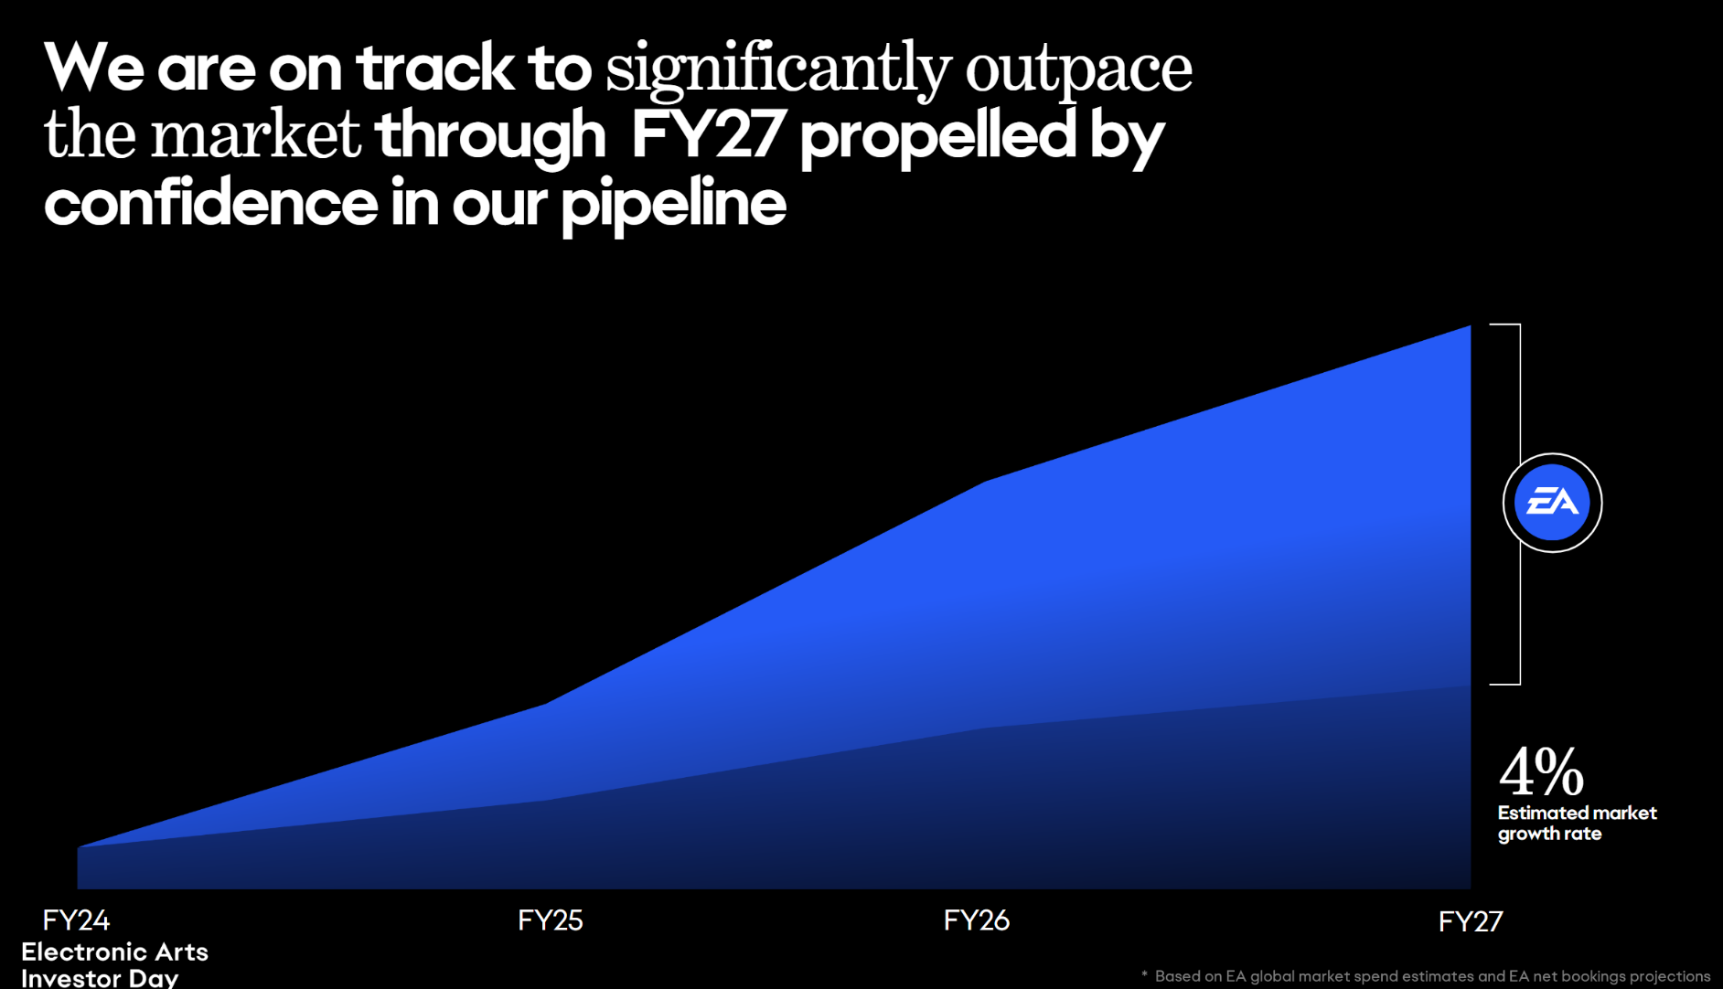

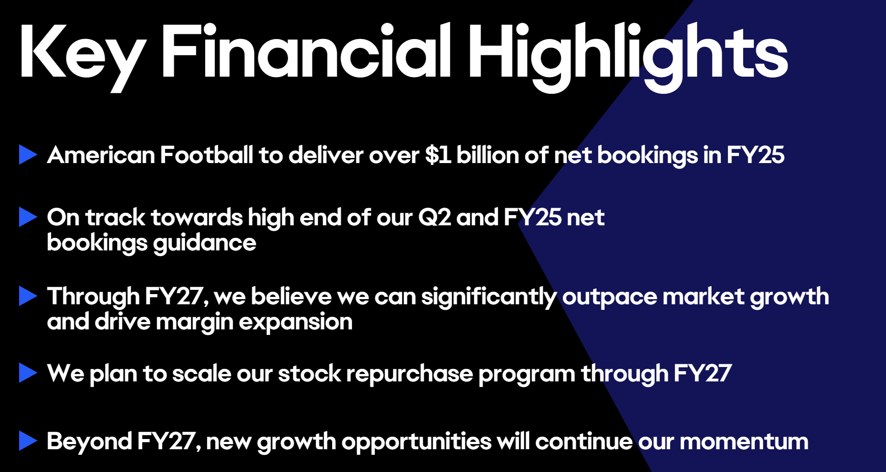

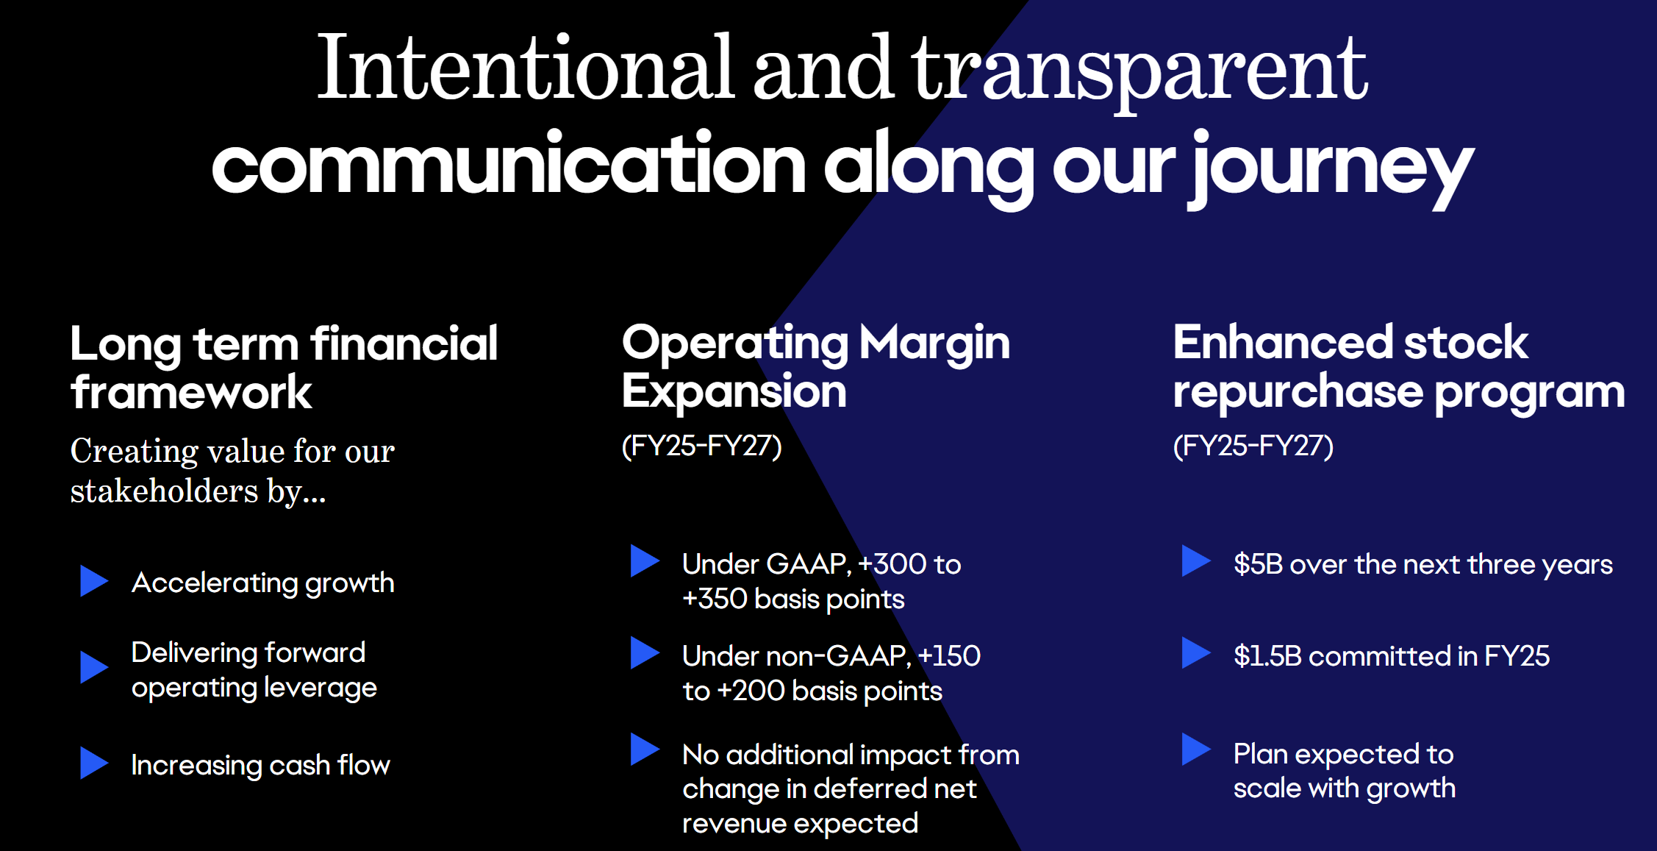

## 9.4.24 - Call w/ Mscience/Corey

EA

* Cannibalization from Madden/CFB
  + Could be bigger in DecQ vs. SepQ b/c SepQ brought in a ton of madden players from CFB
  + Need to CFB and Madden Ultimate together
* Stacked YoY - look at Madden + CFB
  + Tracking in-line y/y for SeptQ
  + Month of Sept, Madden + CFB is tracking flat but up for quarter
* More inclined to see incremental bad news vs. good
* Dragon age game (10.31.24) is likely to underperform
  + Early chatter on game is mixed

TTWO

* NBA
  + units likely impacted by CFB cannibalization
  + But could see rotation back into NBA 2K after launch

Ubisoft

* Underwhelming star wars outlaws

## 

## 8.15.24 - EA hosted by TD Cowen

* + CFB live service momentum and sustainable drivers
    - Cannot give 2Q given we're in quarter
    - We're seeing cohorts of madden in college early on
    - Unique players don’t directly correlate to unit sold b/c of multiple acct per unit…correlation gets wider from 1:1 as we get away from launch date
    - Just launched Madden and going to learn a lot b/t now and end of Sept on cannibalization
  + FC/FIFA Growth Expectations
    - We expect 2025 to grow over 2024
    - New game mode: Rush (5x5 game mode)
    - Rush connects to Ultimate team and has continuity throughout the game which opens up more monetization oppts for more casual players (intimidated by 11x11 game play)
    - 55% of FC unit are sold to those who buy it every year --> need to lift that count on # of annual players
  + Advertising oppt
    - Won't say too much ahead of investor day
    - Advertiser is ONE OF THE PIECEs for business model innovation for FC
    - We're introducing an advertising mechanic that doesn't disrupt game play
    - There's other business models that should show up in 2025
      * e.g. Social mechanics
  + CFB live services
    - We expected live services to look smaller vs. Madden
    - We watching to see if people only build up their own college team or do people build up other college teams…still an unknown
    - We assumed mostly FGD focus and small Live Services vs. Madden (we'll update on 2Q25 eps)
  + Apex legends
    - Product is very high margin…one of the highest in portfolio
    - S22 is still early but Battle Pass change was intended to align more with peers
    - We didn’t assume step function change in apex b/c want to see how S22 plays out
    - Battle Pass - time-bound to shorter period (similar to COD/OverWatch)
      * Goal is to create shorter duration, time-bound with good goals that drives conversion for hardcore cohorts (increases monetization)
      * You have entirety of S22 to complete 1 or both of BP
      * 1st BP for S22 is free if you play in the first week
  + Non-sports mobile % off peak today and oppt for growth
    - Mobile is important growth oppt -- expect msd % growth (vs. prior DD growth)
    - We did sunset products last year to optimize the portfolio
    - Wont launch SA IP unconnected to existing franchises
    - FC mobile seeing pick up in new years
    - Non-sports mobile seeing some greenshoots but expect mobile to be in-line with market at +msd % growth….mostly driven by FC mobile
    - Monopoly go has generated $3b in revenue in 14m months
  + Dragon Age launch & revenue oppt
    - Not yet announced
    - Dragon age inquisition was 10 years ago and market has changed a lot since
    - We have not assumed that its break out hit…
    - Dragon Age will not surpass Star Wars unit solds
    - Dragon age audience is devoted by quite small
  + Changes to Sim game strategy
    - Nothing has changed recently
    - Plan to address it in investor day
    - SIMS is 20yr game that doesn’t even use Season/Battle passes
    - Should have adjacencies with multi-players or going deeper into mobile
    - Overall strategy has become stale
    - Tech on Sim4 wasn’t built as it game would last for decades
  + Details from Gen 9 Install base
    - Still room for install base to grow
    - Some titles not built for Gen8
    - Should expect some slight ASP inflation across major franchises
    - CFB is only on Gen9 (not gen8 or even PC) gives us confidence in Gen9 conversion
  + Expenses - Should we see some relief on cost
    - We've been in investment cycle in last few years
    - Costs ramp and peak close to launch
    - 2025 will continue to be a lot of investment tied to 2026/27 release slate
    - Battlefield is single biggest expense we put in 1 game…we have multiple teams in the project and longest gap b/t BF titles
    - So as BF launches we should see margin improve as expenses dial back (mostly from lower marketing)
  + Thoughts on Nintendo Ecosystem vs. Core PS/Xbox/PC…thoughts on switch refresh
    - We have FC on Nintendo platform for a while
    - But it’s a harder platform for 3P IP… Hardware is more aligned with Nintendo 1P IP.
    - As a result, we have not had a meaningful success on platform…and not invested as much

## 

## 8.12.24 - EA @ OpCo

**Top Questions**

* CFB
  + 5m unique in first week (obviously not a units sold figure) - how to think about the delta to units sold (i.e. count multiple players sharing 1 copy)?
  + Obviously be watching Ultimate team cannibalization --- what steps can you take if things cannibalization is bigger than expected
  + Margin profile vs. Madden?
* EA Sports FC (FIFA)
  + Comping against a >30% bookings growth from 1Q24 but the 2Q comps get harder at +41%
  + Is y/y decline in 2Q potential on the table or does Euro/Copa America give a nice lift
  + EA Sports FC franchise up msd vs. prior version - what does that mean? Last 2 titles vs. prior 2 titles?
* Madden NFL
  + Grew net bookings DD y/y - what are drivers of strength?
  + mostly live services or did units sold grow too?
  + Do comps get harder from lapping on price hikes on Gen8 consoles
* Apex Legends
  + Battle pass walk back more of a function of player outpour?
  + How do you measure whether enough gamers will churn off?
* Mobile
  + Do you expect that mobile can reach lsd exiting this fiscal year or potential to come earlier?
* 5% RIF from Feb-2024
  + When you say to streamline the biz - does that mean this was to reduce managerial layers
* Analyst Day
  + More interested in laying our financial targets or game pipeline?
* Console feature gap b/t Gen 8 vs. Gen9
  + Noticing any divergence in trends in Gen 8 vs. Gen 9 titles
* Strike Impact
  + No impact on anything started before Sept-23…no impact to current development titles. I.e. not battlefield?
  + What title could this show up in first?

-------------------

**EA IR (Andrew Uerkwitz & Cam Weber) - 8.12.24**

* CFB - will now be annual title?
  + Game is basically being self-promoted via 11k athletes signup
  + We have long-term multi-year deal with CLC and licensing permission to do multi-year
  + We will spend more on college than we anticipated b/c its so succecssful
  + We have not announced a new launch but have right too
  + We focused on getting people to buy both products…we've had tremendous pick up with MVP
  + Madden pre-orders are very strong driven by bundle strength
  + Investing to connect the gameplay with Madden and College…Players can import their content from one game to another
* Any live service contribution in F25?
  + Some live service in FY25 guidance
  + Primary mode are dynasty or road to glory -- assume smaller contribution than Madden or FC on per player basis b/c people tend to follow their teams
  + Same game play mode as madden
  + Got to play as 100 of the biggest NFL players when they were in their college period
  + We're very conservative on live service contribution for CFB -- College ultimate team is going VERY VERY WELL
* Cannibalization on CFB vs. Madden
  + Assume fewer madden units but higher ASP…revenue accretive
  + Margins are much better on college title b/c of licensing savings
  + Heard from console makers that CFB driving more relativization in console usage
  + Madden pre-orders are tracking ahead of what they normally do - primarily driven by MVP bundle…College is bringing in players who did not play Madden LY
  + Margin delta is licensing related -- cheaper to pay 11k students $600 than to pay the NFL
* 5m unique translates
  + Early in launch cycle should expect it to be 1 for 1
  + But tends to get wider longer in the cycle
* Room to take up ASP price
  + More broadly want to push people into higher SKU (deluxe or MVP SKU to play early access)
  + MVP driving a lot of sell-in --> benefits to ASP via mix
  + Leave the pricing up to the studios… don't invest as much in core gameplay in prior generation
  + Smaller games will drop off their older gen SKU earlier
  + Madden still will have gen 8 SKUs
* How to think about Analyst Day
  + 2 big takeaways
    - Robust pipeline across all franchises…plenty of growth across FIFA/Madden to keep growing. EA Entertainment (Non-sports): need to understand how to deliver on battlefield, SIMs
    - What we're doing around/beyond our games that can drive results
  + 2 new mobile games coming to FC universe
* Apex legends - decision to rollback monetization change…how critical was monetization to stabilization of apex
  + Decision to change battle pass was done by Apex team…not a financial team
  + If you don't szn pass in first 3-4wk then you just don’t buy it….
  + 100 levels is too overwhelming, so split it in 2 two (60 levels) with 12wks per szn pass
  + Data suggest that vast majority were not using virtual currency anyway to buy pass…we rolled that back and gave first szn pass away for free
  + Very little impact, but created negative sentiment with start of the season
  + More challenging to see greenshoots in S22 and S23 for apex legends
* Breathing room from GTA 6 launch in Fall 2025
  + BF team has completion date in mind
  + GTA 6 announce won't impact completion date but will impact launch window
  + Launch window matter for everything except for sports
  + Hard to put a 2-month window out there
* Strength drivers for Madden NFL 24
  + WAU were up for Madden but not attributable to CFB
  + Madden 24 has great momentum that strengthened through the year (gap vs. Madden 23 kept growing as time went on)

## 

## 6.18.24 - MN hosts EA Mgmt

**GM/SVP of Publishing at EA Sports**

* FC Competitive position given FIFA brand licensing?
  + Not going to comment on rumors
* FIFA rebrand
  + One of biggest rebrand in media
  + ~55% of our audience comes back on an annual basis
  + We had strong FIFA 23
  + FC has be able to integrate real world event (Euro Cup) as well as our own event (team of the year)
* How to think about exclusive vs. non-exclusive rights
  + We have 300 licensing partners for our game
  + Everyone is part of strategy for authentic simulation (athletic in uniform)
  + FIFA licensing as important as other league licensing
  + We also do marketing deal with top-tier clubs
* Level of investment for EA FC Sports
  + We have >1k developers working on this game globally
  + We have 8 studios globally
  + We fully expect FIFA to try to find a new buyer as they lost a sizeable licensing fee
  + Our move away from FIFA allows us to work with more licensing (coke & pepsi, nike & addidas)…so we could open up more advertising partnerships that we couldn’t before
* American football - size of college vs. Madden? An integrated experience potential?
  + Impressive metrics but historically college small % of madden…but game has not been around for 10 yrs
  + We're tempering expectations just b/c college football does not have global appeal
  + Called EA Sports College Football (not NCAA anymore)
  + We've been out of market for 11 years … so a lot of pent up demand
  + 134 FBF schools signed up to be apart of the game
  + We allowed every athlete ability to opt-in (11.5k opt-in) after NIL changes
  + We had 25m views on Trailer in first 24 hrs
  + Our integrated experience b/t College and Madden via Ultimate Team
* Cannibalization effect of college on Madden
  + We don’t comment on pre-orders -- sales curve will be very different than annual titles (no reason to pre-order annual titles)
  + We've built in some cannibalization into Madden…also coming off record year in Madden
  + We're offering $150 bundle (Madden + CFB Deluxe -- $100 SA price)
  + NFL has group license…and only 2 (exclusive license). We've had it for many years and NFL has not sought other partners
* College Football to be annualized title? Ramp of Live Services?
  + Yes - we will annualize the title
  + Live Services is a big portion of our biz - so we're going to focus on building it…may take us time to learn and refine

## 5.21.24 - EA @ JPM

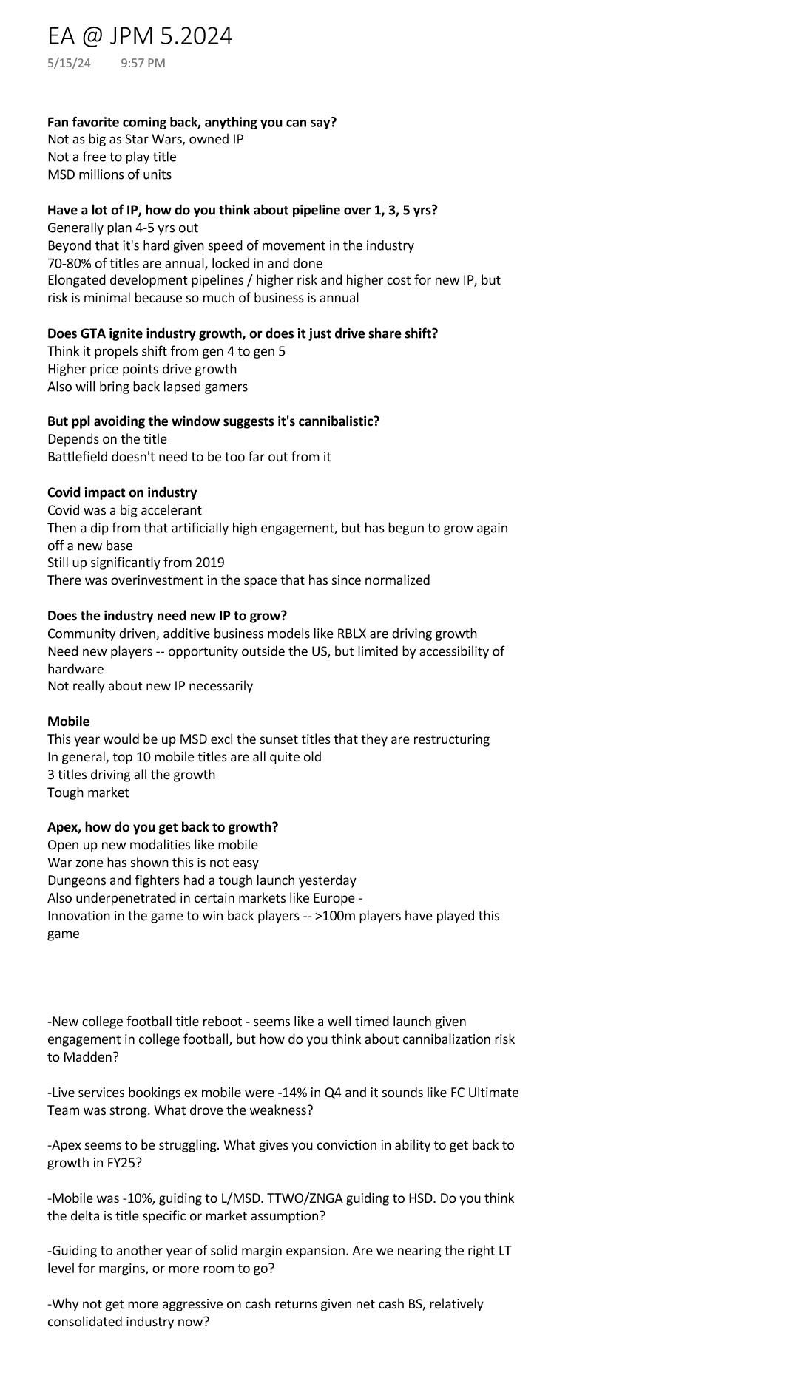

## 5.23.24 - EA CFO @ Stifel

**Net:** Sounded pretty optimistic on NCAA football but given pent up demand the unit curve will not look like Madden…More like Diablo, so cannot get overly bullish on pre-sale uptick and clearly there's cannibalistic potential for live services. EA views first launch as a "learning" opportunity so will be flexible to pivot the model. EA seems skeptical about GTA 6 actually coming Fall 2025 and they told their dev team to just continue on building the game. They will be deliberate about not launching during same week of GTA but not as concerned about CoD launch overlap. EA's gave a quick outline of their NYC Sept-24 Aday which should show LT growth and margin targets and a look at potential pipeline.

No real change to numbers here but context on unit curve is helpful. There's a couple of model cleanup items coming out of the call but I don’t anticipate numbers moving materially.

——

* NCAA football
  + Huge missing component was NIL rules in college football
  + 20m views on trailer and growing
  + This year will be more robust than other b/c of gap in content will support strong pre orders
  + We have high expectations but also being realistic
  + We’re guiding based on NFL - unclear how the dynamics
  + We launched the bundle SKU - $150 for both games
  + Live services will be very similar to Madden
    - Question is do ppl spend time building a team across multiple college or stay within their own team (Umich only team)
    - Professional teams have more brand affinity
  + Hard to know where monetization will be for NCAA
  + We could be completely wrong in year 1
  + Deal terms are public - all athletes have the deal
  + We should annualize the title…multi-year
  + Transfer portal is a big change agent —> makes the game stale every year b/c 50% of athletes are in the portal
  + We have aspirations of getting American football (NFL + college) to over a 1b in bookings
  + Synergies from ecosystem? We’ll see more at Sept Investor Day
* Pullfwd dynamics
  + We know there’s built up de
  + Don’t compare the curve to madden or NBA - b/c not an annualized game…long wait time for reboot
  + This could be more similar to Diablo - anticipation for a decade
* Linearity of growth
  + Starting down 9% a.f. Slate
  + Tough comps FIFA and Apex
  + World Cup pushed out live services 1 quarter back
  + FC was +2% off +20%
  + 15pt headwind from Jedi coming out of comp
* FIFA - how to think about growth dynamics
  + Euro championship in June/July
  + Grown every year
  + Timing is later in the quarter
  + Premier league is the most played
  + Licensing payments are 0 this fiscal year
  + 8 months out of last Fiscal year
* FIFA advertising
  + No advertising today
  + Thinking about building ad tech stack - could do in-market
  + We couldn’t have partnership with certain folks outside of FIFAs control
* Apex
  + Can work out the headwind we faced last year based on math in script
  + Success of seasons is varied…
  + We’re moving away from globalized service to more local/in-market services
    - I.e. each region has its own live service flavor
  + Grow engagement and retention first
  + Game took off so fast we had to roll with the Monetization structure
* Battlefield
  + Still need clarity on GTA and CoD to our ship time
  + BF wont be moved on COD but will be around BF
  + We are not mandated RTO
  + 4 different studios across
  + Live services is a separate team within each team
  + Bryone came over from CoD
    - Our mentality is different with new BF
  + Team has been working on BF 2042 in the interim
* Investor Day
  + Sept-24 in NYC
  + Date forthcoming - won’t overlap with GS conf
  + Conviction on LT target and margins + capital return
  + Won’t give too much competitive insights

# 

# FC

EA SPORTS FC 2024 (9.24.24) - [Electronic Arts Inc. - EA SPORTS FC 24 Launches Worldwide Today - A New Era Begins for the World's Game](https://ir.ea.com/press-releases/press-release-details/2023/EA-SPORTS-FC-24-Launches-Worldwide-Today---A-New-Era-Begins-for-the-Worlds-Game/default.aspx)

* *More Than 6.8 Million Players Have Hit The Pitch in* *The Football Franchise’s Biggest Early Access Audience To Date*
* *Featuring over 19,000 fully licensed players, 700 teams, and 30 leagues including the Premier League, LALIGA EA SPORTS, UEFA Men’s and Women’s Champions League, CONMEBOL Libertadores, and more*
* Fans are invited to join the club alongside the 6.8 million players who have already played EA SPORTS FC 24 through Early Access, an increase of over 25% from last year (Percentage increase calculated using data from last year’s early access period of 3 days and EA SPORTS FC 24’s early access period of 7 days.)